Topic :- Learning disability
Here are a few general tips: make sure you start with the ancient past, don't skip the middle ages, have strong transitions that show me your critical thinking on this subject and make sure your future section is your specific and developed thoughts on what is next for this topic. Make sure you also pick a current researcher in the field.
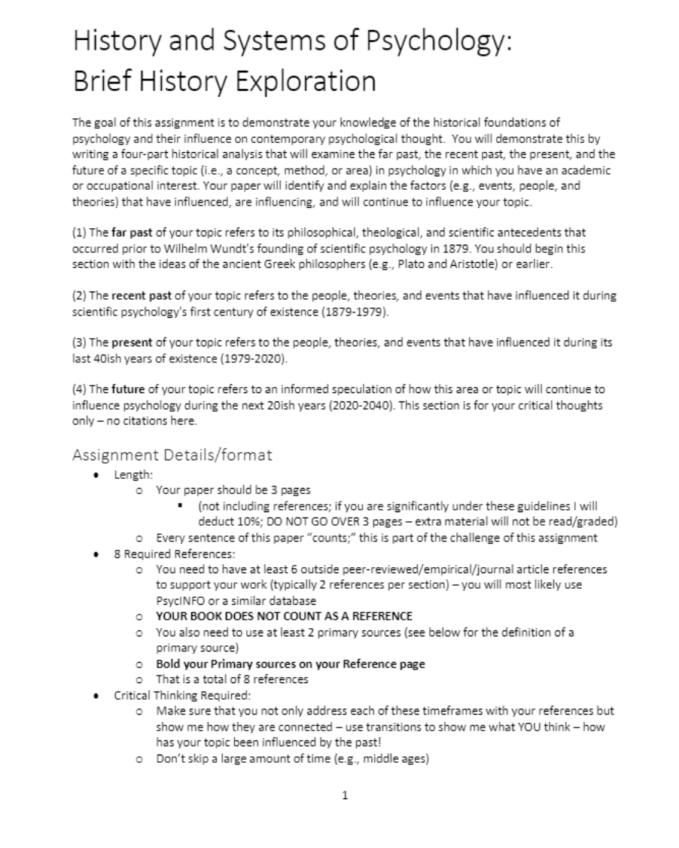
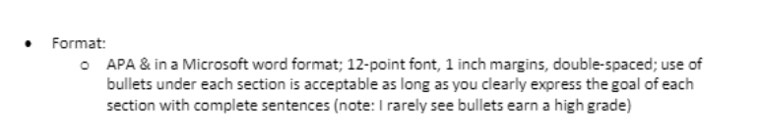
Grading Rubric
